How to change your Favourite round
1. Select either the “Score” or “Plot” tab. The “Plot” tab is selected in the screenshot below.
2. Tap on the icon  at the top right of the screen.

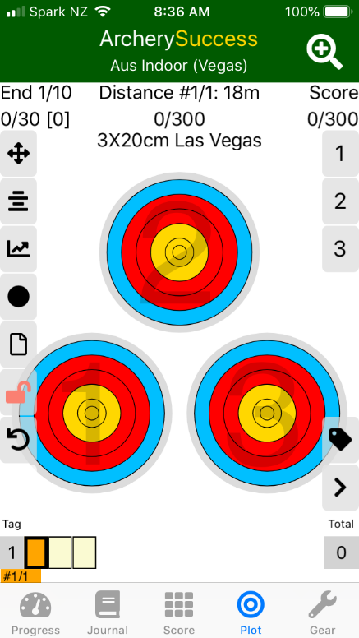
3. The “Select a Round” screen will open. (screenshot below)

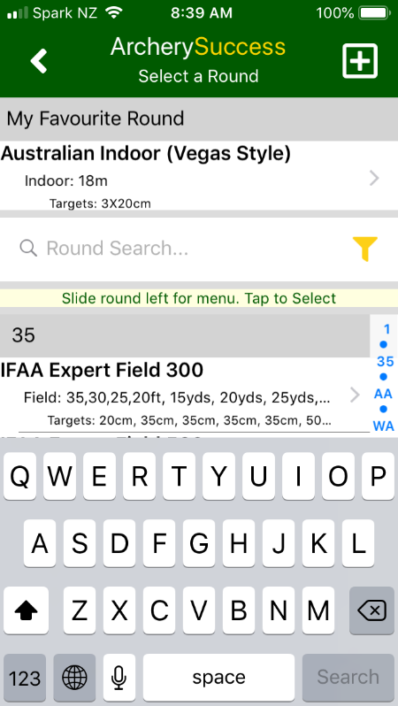
4. Search for the round you want to change to your new favourite round by typing in the search box. (We are using NFAA as an example in the screenshot below)
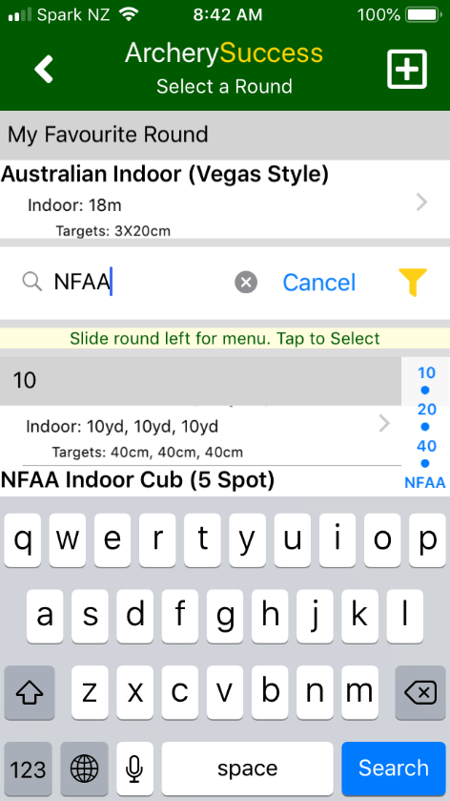
5. On Apple: Slide the round that you want to make your new favourite round to the left. This will reveal two options “Favourite” and “Detail” as per the screenshot below.
On Android: Press and hold the round which you want to make your new favourite round. This will reveal two options “Favourite” and “Detail” at the top of the page
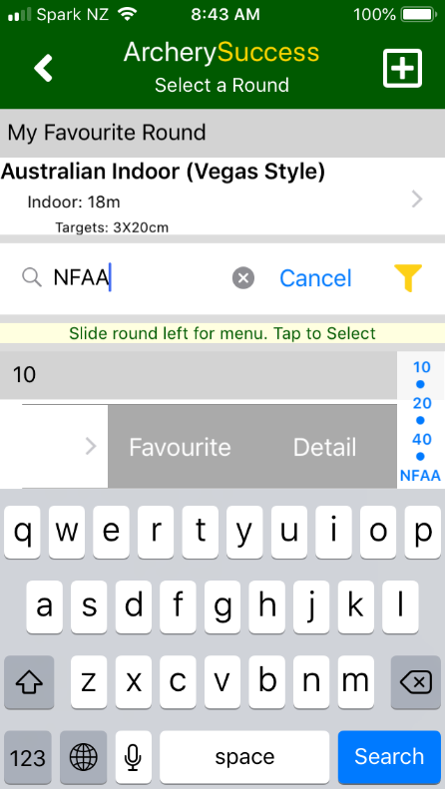
6. Tap on “Favourite” and the app will change the Favourite round from “Australian Indoor” in screenshot above to the round we selected to be the favourite round “NFAA Indoor Club (5 Spot)” as shown in screenshot below.
